AHCA Culture of Safety — Data Revalidation

Patient Safety Culture Survey: Submission Data Review
Identifying and correcting a reverse-worded scoring error in Ascension Florida’s 2024 AHCA hospital submission

Prepared by Beterra
Date June 2026
For Ascension Florida Leadership

Section 1

Executive summary
In September 2024, Ascension Florida fielded the AHRQ Survey on Patient Safety Culture (Hospital version) across eight hospitals and submitted the results to the Agency for Health Care Administration (AHCA). During revalidation, Beterra identified that a defined set of negatively-worded (“reverse-worded”) questions had their responses inverted at the response level before scoring.
AHCA scoring counts a 4 or 5 (Agree / Strongly Agree) as positive for every question. Inverting the responses to negatively-worded questions therefore distorts exactly the composite measures that contain them — depressing Staffing and Work Pace, Response to Error, Handoffs, and related measures — while leaving every composite without a reverse-worded question unchanged.
This review is scoped to the eight hospitals, which is the level at which data is submitted to AHCA. It documents, from the ground up, how the data moved from collection to submission, which questions are affected and why, and the difference between the figures as originally submitted and the corrected results. An Ascension Florida system roll-up is included as supplementary context.
Key takeaway
Thirteen negatively-worded questions were inverted before scoring. Correcting them changes only the composites that contain those questions; measures with no reverse-worded questions are identical in both versions, confirming the rest of the data is sound.

Section 2

Background and scope
The review covers eight Ascension Florida hospitals in two regions. Sacred Heart West: Pensacola, Gulf, Emerald Coast, and Bay. Jacksonville East: St. Vincent’s Southside (St. Luke’s), Riverside (St. Vincent’s Medical Center), Clay County, and St. John’s County.
The instrument is the AHRQ Survey on Patient Safety Culture (SOPS), Hospital version, administered by the prior survey vendor and entered into AHCA’s Hospital Survey data-entry tool. Only the hospital surveys were required for the AHCA submission; other care settings are out of scope.
Section 3

How the survey is scored
Each scored question uses a five-point scale. AHCA reports each result as a percent positive — the share of responses that are 4 or 5, with neutral responses counted in the denominator. The same rule applies to every question.
Most questions are positively worded (“we work together as an effective team”) — agreement is good. Thirteen are negatively worded (“staff feel like their mistakes are held against them”) — agreement is bad. For the uniform 4/5-is-positive rule to score these correctly, the response must be stored in the correct (reversed) orientation. Inverting a negatively-worded response a second time makes the score count backwards.

Composites and where the reverse-worded questions sit
The scored questions roll up into ten composites. The table shows how many questions each contains and how many are reverse-worded — which determines whether the error can affect it.
Composite | Questions | Reverse-worded | Affected?
Teamwork | 3 | 1 | Yes
Staffing and Work Pace | 4 | 3 | Yes
Organizational Learning – Continuous Improvement | 3 | 1 | Yes
Response to Error | 4 | 3 | Yes
Supervisor / Manager Support | 3 | 1 | Yes
Communication Openness | 4 | 1 | Yes
Communication About Error | 3 | 0 | No — unaffected
Hospital Management Support | 3 | 1 | Minimal (1 of 3)
Handoffs and Information Exchange | 3 | 2 | Yes
Reporting Patient Safety Events | 2 | 0 | No — unaffected

Table 1. Communication About Error and Reporting Patient Safety Events contain no reverse-worded questions and are unaffected.

The thirteen reverse-worded questions
Item | Composite | Question wording
A3 | Staffing and Work Pace | Staff in this unit work longer hours than is best for patient care.
A5 | Staffing and Work Pace | This unit relies too much on temporary, float, or PRN staff.
A6 | Response to Error | In this unit, staff feel like their mistakes are held against them.
A7 | Response to Error | When an event is reported in this unit, it feels like the person is being written up, not the problem.
A9 | Teamwork | There is a problem with disrespectful behavior by those working in this unit.
A11 | Staffing and Work Pace | The work pace in this unit is so rushed that it negatively affects patient safety.
A13 | Response to Error | In this unit, there is a lack of support for staff involved in patient safety errors.
A14 | Organizational Learning – Continuous Improvement | This unit lets the same patient safety problems keep happening.
B2 | Supervisor / Manager Support | My supervisor, manager, or clinical leader wants us to work faster during busy times, even if it means taking shortcuts.
C7 | Communication Openness | In this unit, staff are afraid to ask questions when something does not seem right.
F3 | Hospital Management Support | Hospital management seems interested in patient safety only after an adverse event happens.
F4 | Handoffs and Information Exchange | When transferring patients from one unit to another, important information is often left out.
F5 | Handoffs and Information Exchange | During shift changes, important patient care information is often left out.

Section 4

How the data moved — and where it diverged
The survey data passed through four points. Perceptyx survey and reporting: the vendor collected the responses and reported results correctly. Perceptyx data export: the vendor’s raw data file, however, normalized the thirteen reverse-worded items — storing them pre-inverted so that a uniform 4/5-is-positive rule scores them correctly inside the vendor’s own system. AHCA data-entry tool: Ascension loaded that export into AHCA’s macro-enabled Excel tool, which applies standard reverse-scoring and so expects un-normalized responses — it did not account for the vendor’s normalization. Submission: the tool produced the per-facility files for AHCA’s system with the reverse-worded items still normalized, so AHCA’s scoring counted them backwards.
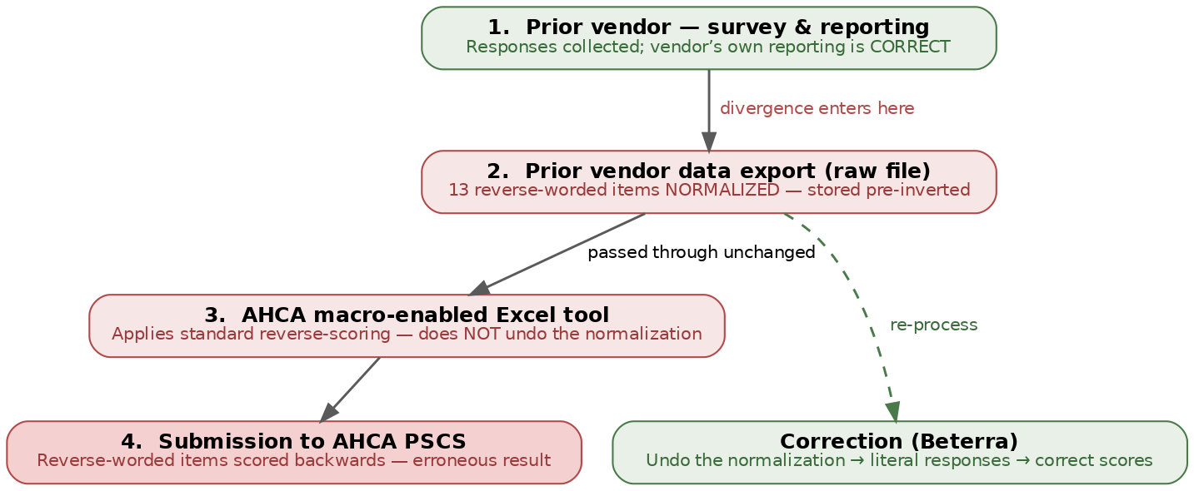
Figure 1. The data chain. The error originates in the Perceptyx export (reverse-worded items normalized) and is carried unchanged through the AHCA tool into the submission; the correction undoes the normalization.
The table traces a control question (A1, positively worded) and a reverse-worded question (A3) through these points, pooled across all eight hospitals. The reverse-worded value is identical from the Perceptyx export through the AHCA submission — the tool passed it through unchanged — and moves only when the normalization is undone in the corrected data. The control question is stable everywhere.
Stage | A1 — control (% positive) | A3 — reverse-worded (% positive)
Perceptyx source export | 88.5% | 20.8%
AHCA tool submission (as submitted) | 88.5% | 20.8%
Corrected (literal responses) | 88.5% | 50.8%

Table 2. Chain of custody, pooled across eight hospitals. The reverse-worded item is unchanged from export to submission and diverges only when the normalization is reversed; the control item is stable throughout.
Perceptyx’s own facility reports corroborate this: for Sacred Heart Emerald Coast the vendor report shows Teamwork 88.6% and “staff work longer hours than is best for patient care” at 53.4% — matching the corrected figures, not the submitted ones. Perceptyx analyzed the data correctly; the error entered at the export-to-AHCA-tool handoff and was never reversed before submission.
Section 5

The defect and how we confirmed it
For each of the thirteen reverse-worded questions, every response was replaced by its inverse on the 1–5 scale (a 1 became a 5, a 2 a 4, and so on). Comparing the affected and corrected datasets respondent-by-respondent, the inversion is exact and complete: across more than 3,800 matched respondents, 100% of non-neutral responses to these thirteen questions are inverted, with no exceptions, and no other questions are touched.
The clearest illustration is a single question’s response distribution. On item B2 (“my supervisor wants us to work faster … even if it means taking shortcuts”), staff overwhelmingly disagreed (responses 1–2) — the favorable answer. In the submitted data these responses were inverted to agreement (4–5), an exact mirror image (scale: 1 = Strongly Disagree, 5 = Strongly Agree):
Response distribution (B2) | 1 | 2 | 3 | 4 | 5
Corrected (as answered) | 29.2% | 47.8% | 14.5% | 5.3% | 3.2%
As submitted (inverted) | 3.2% | 5.3% | 14.5% | 47.8% | 29.2%

Table 3. Corrected percentages are the literal responses from the analytics system (response_breakdown, survey_ids 3434–3441); the submitted distribution is their exact 1↔5 / 2↔4 inversion — the signature of a response-level flip.
Section 6

Impact: corrected versus submitted results
The table below shows each hospital’s overall percent positive as submitted versus corrected. All figures are the official scored values from the analytics system.
Hospital | Corrected | As submitted | Change
Sacred Heart Pensacola | 70.5% | 53.8% | +16.7
Sacred Heart Gulf | 82.6% | 54.5% | +28.1
Sacred Heart Emerald Coast | 72.6% | 53.7% | +18.9
Sacred Heart Bay | 58.6% | 49.9% | +8.7
St Vincent’s Southside (St Luke) | 67.3% | 52.1% | +15.1
St Vincent’s Riverside (St Vincent Medical Center) | 67.5% | 53.8% | +13.7
St Vincent’s Clay County | 70.2% | 53.3% | +16.9
St Vincent’s St John’s County | 75.6% | 55.0% | +20.7

Table 4. Overall percent positive by hospital (response-weighted across composites).

Where the change concentrates
Across all eight hospitals, the gap falls entirely on composites containing reverse-worded questions. Communication About Error and Reporting Patient Safety Events do not move; Hospital Management Support moves only slightly (it has a single reverse-worded question).
Composite (all hospitals) | Corrected | As submitted | Change
Teamwork | 81.6% | 64.1% | +17.5
Staffing and Work Pace | 53.9% | 29.4% | +24.5
Organizational Learning – Continuous Improvement | 68.8% | 50.3% | +18.5
Response to Error | 61.5% | 28.0% | +33.6
Supervisor / Manager Support | 79.6% | 56.7% | +22.8
Communication Openness | 75.9% | 60.5% | +15.4
Communication About Error (unaffected) | 73.7% | 73.7% | +0.0
Hospital Management Support (minimal) | 54.8% | 56.2% | -1.4
Handoffs and Information Exchange | 61.7% | 37.8% | +23.9
Reporting Patient Safety Events (unaffected) | 80.3% | 80.3% | +0.0

Table 5. Composite percent positive across all eight hospitals (response-weighted). Per-hospital detail is in data/compare_corrected_vs_raw.csv.
Section 7 — Supplementary

Ascension Florida system roll-up
Provided as additional context (not part of the facility-level resubmission), the system roll-up shows the same pattern at the aggregate level.
Composite (system) | Corrected | As submitted | Change
Teamwork | 81.6% | 64.1% | +17.5
Staffing and Work Pace | 53.9% | 29.4% | +24.5
Organizational Learning – Continuous Improvement | 68.7% | 50.2% | +18.5
Response to Error | 61.6% | 28.0% | +33.6
Supervisor / Manager Support | 79.5% | 56.7% | +22.8
Communication Openness | 75.9% | 60.5% | +15.4
Communication About Error | 73.7% | 73.7% | +0.0
Hospital Management Support | 54.8% | 56.2% | -1.4
Handoffs and Information Exchange | 61.7% | 37.8% | +23.9
Reporting Patient Safety Events | 80.3% | 80.3% | +0.0

Table 6. Ascension Florida system composite percent positive (supplementary).
Section 8

Conclusion and next steps
The submitted figures understate patient safety culture at the affected composites because of a response-level inversion of thirteen negatively-worded questions — introduced in the Perceptyx export and not reversed by the AHCA data-entry tool. The corrected, validated results are ready for resubmission at the facility level.

Next steps
AHCA resubmission — corrected facility files are validated and ready; target submission date [to be confirmed].
Leadership communication — executive / CEO memo summarizing the issue and remediation; audience and timing [to be confirmed].
Recurrence prevention — confirm the reverse-worded normalization convention with the vendor and in the AHCA tool workflow [to be confirmed].
Owner and timeline — responsible party and key dates [to be confirmed].
Placeholder — to finalize
Confirm the four items above (resubmission date, leadership communication, recurrence-prevention step, and owner/timeline) before this report is issued.

https://beterra-presents-ahca.floridasafetyculture.com
https://beterra-presents-ahca.floridasafetyculture.com/compare “Distribution – All FL Hospitals”
https://beterra-presents-ahca.floridasafetyculture.com/compare “Composite Comparison Table”

